## **Objectives**

* List the features of ES6
* Explain JavaScript let
* Identify the differences between var and let
* Explain JavaScript const
* Explain ES6 class fundamentals
* Explain ES6 class inheritance
* Define ES6 arrow functions
* Identify set(), map()

In this hands-on lab, you will learn how to:

* Use map() method of ES6
* Apply arrow functions of ES6
* Implement Destructuring features of ES6

## **Prerequisites**

The following is required to complete this hands-on lab:

* Node.js
* NPM
* Visual Studio Code

## **Notes**

Estimated time to complete this lab: **60 minutes.**

Create a React Application named “cricketapp” with the following components:

1. ListofPlayers

* Declare an array with 11 players and store details of their names and scores using the map feature of ES6

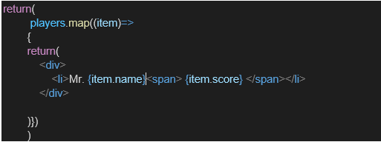

* Filter the players with scores below 70 using arrow functions of ES6.

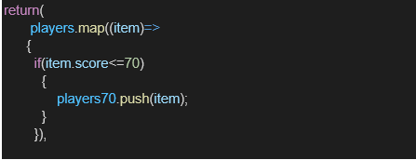

1. IndianPlayers
   1. Display the Odd Team Player and Even Team players using the Destructuring features of ES6

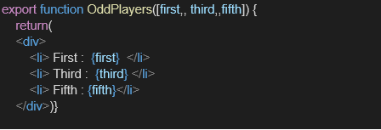

* 1. Declare two arrays T20players and RanjiTrophy players and merge the two arrays and display them using the Merge feature of ES6

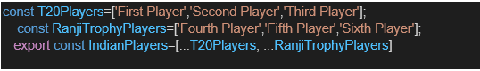

Display these two components in the same home page using a simple if else in the flag variable.

**Output:**

When Flag=true

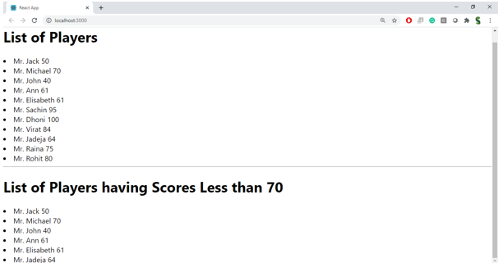

When Flag=false

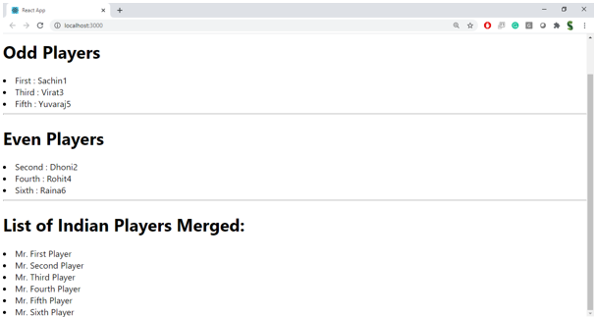

**Hint:**

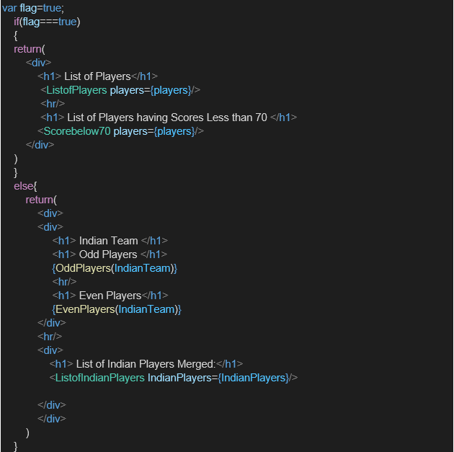

**Sample Input code :**

**App.js:**

import React from 'react';

import ListofPlayers from './Components/ListofPlayers';

import Scorebelow70 from './Components/Scorebelow70';

import OddPlayers from './Components/OddPlayers';

import EvenPlayers from './Components/EvenPlayers';

import ListofIndianPlayers from './Components/ListofIndianPlayers';

function App() {

  const flag = true; // Change to false to test other view

  const players = [

    { name: 'Mr. Jack', score: 50 },

    { name: 'Mr. Michael', score: 70 },

    { name: 'Mr. John', score: 40 },

    { name: 'Mr. Ann', score: 61 },

    { name: 'Mr. Elisabeth', score: 61 },

    { name: 'Mr. Sachin', score: 95 },

    { name: 'Mr. Dhoni', score: 100 },

    { name: 'Mr. Virat', score: 84 },

    { name: 'Mr. Jadeja', score: 64 },

    { name: 'Mr. Raina', score: 75 },

    { name: 'Mr. Rohit', score: 80 },

  ];

  const IndianTeam = ['Sachin1', 'Virat3', 'Yuvaraj5', 'Dhoni2', 'Rohit4', 'Raina6'];

  const IndianPlayers = ['Mr. First Player', 'Mr. Second Player', 'Mr. Third Player', 'Mr. Fourth Player', 'Mr. Fifth Player', 'Mr. Sixth Player'];

  if (flag === true) {

    return (

      <div>

        <h1>List of Players</h1>

        <ListofPlayers players={players} />

        <hr />

        <h1>List of Players having Scores Less than 70</h1>

        <Scorebelow70 players={players} />

      </div>

    );

  } else {

    return (

      <div>

        <h1>Indian Team</h1>

        <h1>Odd Players</h1>

        <OddPlayers players={IndianTeam} />

        <hr />

        <h1>Even Players</h1>

        <EvenPlayers players={IndianTeam} />

        <hr />

        <h1>List of Indian Players Merged:</h1>

        <ListofIndianPlayers IndianPlayers={IndianPlayers} />

      </div>

    );

  }

}

export default App;

**Scorebelow70.js:**

import React from 'react';

function Scorebelow70({ players }) {

  const filteredPlayers = players.filter(player => player.score < 70);

  return (

    <ul>

      {filteredPlayers.map((player, index) => (

        <li key={index}>

          {player.name} - Score: {player.score}

        </li>

      ))}

    </ul>

  );

}

export default Scorebelow70;

**Oddplayers.js:**

import React from 'react';

function OddPlayers({ players }) {

  const oddPlayers = players.filter((_, index) => index % 2 === 0); // 0-based index: 0,2,4...

  return (

    <ul>

      {oddPlayers.map((player, index) => (

        <li key={index}>{player}</li>

      ))}

    </ul>

  );

}

export default OddPlayers;

**EvenPlayers.js**

import React from 'react';

function EvenPlayers({ players }) {

  const evenPlayers = players.filter((_, index) => index % 2 === 1); // 0-based index: 1,3,5...

  return (

    <ul>

      {evenPlayers.map((player, index) => (

        <li key={index}>{player}</li>

      ))}

    </ul>

  );

}

export default EvenPlayers;

**IndianPlayers.js:**

import React from 'react';

const IndianPlayers = () => {

  const oddTeam = ['Sachin1', 'Virat3', 'Yuvaraj5'];

  const evenTeam = ['Dhoni2', 'Rohit4', 'Raina6'];

  // Destructuring odd and even team

  const [odd1, , odd3] = oddTeam;

  const [even1, even2, even3] = evenTeam;

  const T20Players = ['Mr. First Player', 'Mr. Second Player', 'Mr. Third Player'];

  const RanjiPlayers = ['Mr. Fourth Player', 'Mr. Fifth Player', 'Mr. Sixth Player'];

  const mergedPlayers = [...T20Players, ...RanjiPlayers]; // Using spread operator

  return (

    <div>

      <h2>Odd Players</h2>

      <ul>

        <li>First : {odd1}</li>

        <li>Third : {odd3}</li>

      </ul>

      <h2>Even Players</h2>

      <ul>

        <li>Second : {even1}</li>

        <li>Fourth : {even2}</li>

        <li>Sixth : {even3}</li>

      </ul>

      <h2>List of Indian Players Merged:</h2>

      <ul>

        {mergedPlayers.map((player, index) => (

          <li key={index}>{player}</li>

        ))}

      </ul>

    </div>

  );

};

export default IndianPlayers;

**ListofPlayers.js:**

import React from 'react';

const ListofPlayers = () => {

  const players = [

    { name: 'Mr. Jack', score: 50 },

    { name: 'Mr. Michael', score: 70 },

    { name: 'Mr. John', score: 40 },

    { name: 'Mr. Ann', score: 61 },

    { name: 'Mr. Elisabeth', score: 61 },

    { name: 'Mr. Sachin', score: 95 },

    { name: 'Mr. Dhoni', score: 100 },

    { name: 'Mr. Virat', score: 84 },

    { name: 'Mr. Jadeja', score: 64 },

    { name: 'Mr. Raina', score: 75 },

    { name: 'Mr. Rohit', score: 80 },

  ];

  const below70 = players.filter(player => player.score < 70);

  return (

    <div>

      <h2>List of Players</h2>

      <ul>

        {players.map((player, index) => (

          <li key={index}>{player.name} {player.score}</li>

        ))}

      </ul>

      <hr />

      <h2>List of Players having Scores Less than 70</h2>

      <ul>

        {below70.map((player, index) => (

          <li key={index}>{player.name} {player.score}</li>

        ))}

      </ul>

    </div>

  );

};

export default ListofPlayers;

**Sample Output:**

